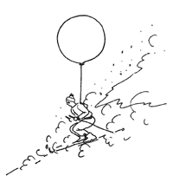

**Earthquake**

**Tsunami**

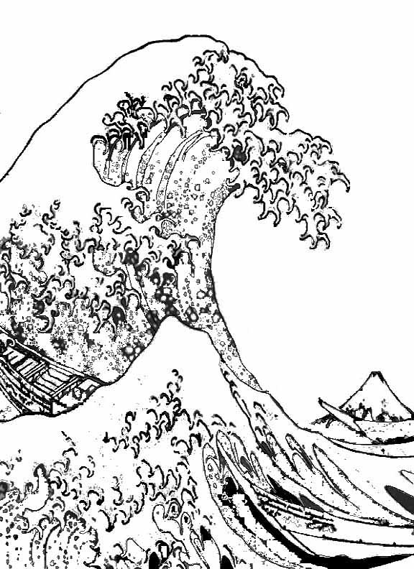

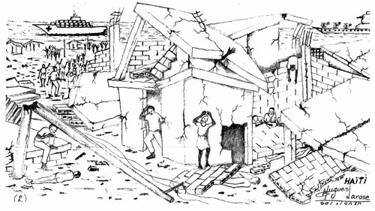

... is a series of gigantic water waves that causes a surge of water onto land.

... are used to describe the sudden release of energy in the earth’s crust causing movement.

**Drought**

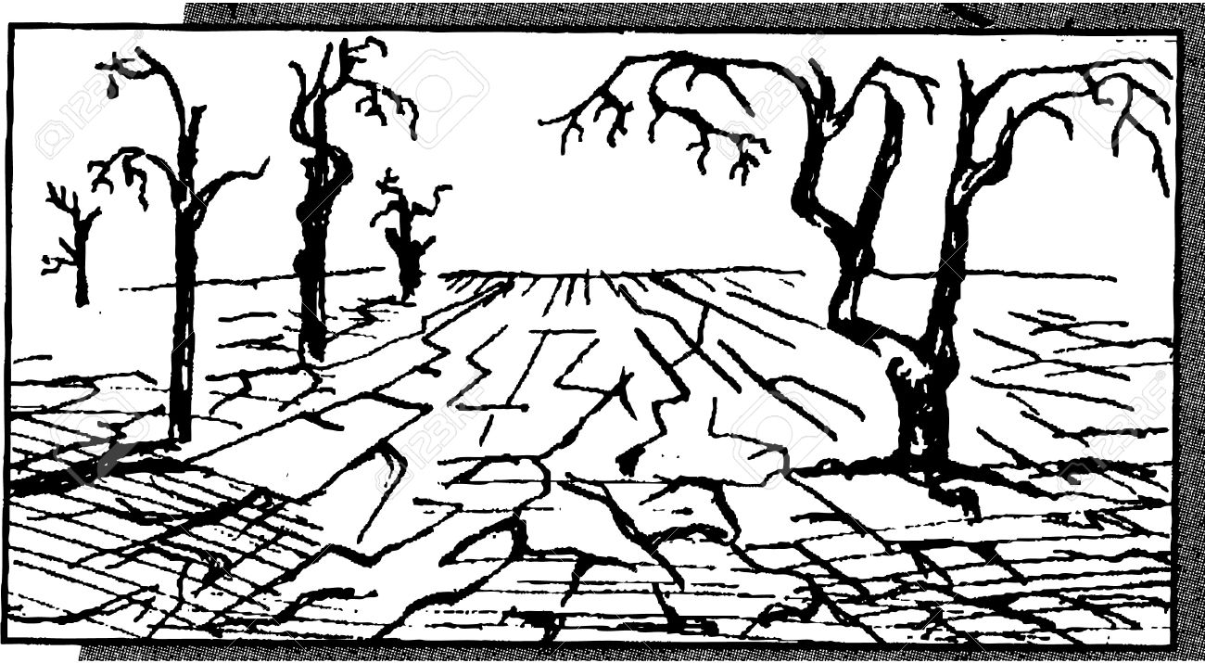

**Hail**



... are made up of water ice and can be any size. are produced during thunderstorms and heavy rains.

... is a lengthy period of time that land has a decrease in water supply.

... is the gravity that forces the debris and rocks to fall and for a total landslide to occur.

**Landslides**

**volcanic eruption**

... the volcano sends out ash clouds, lava and even volcanic bombs.

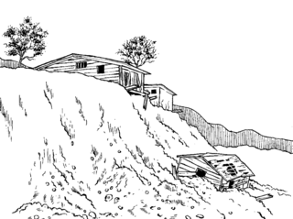

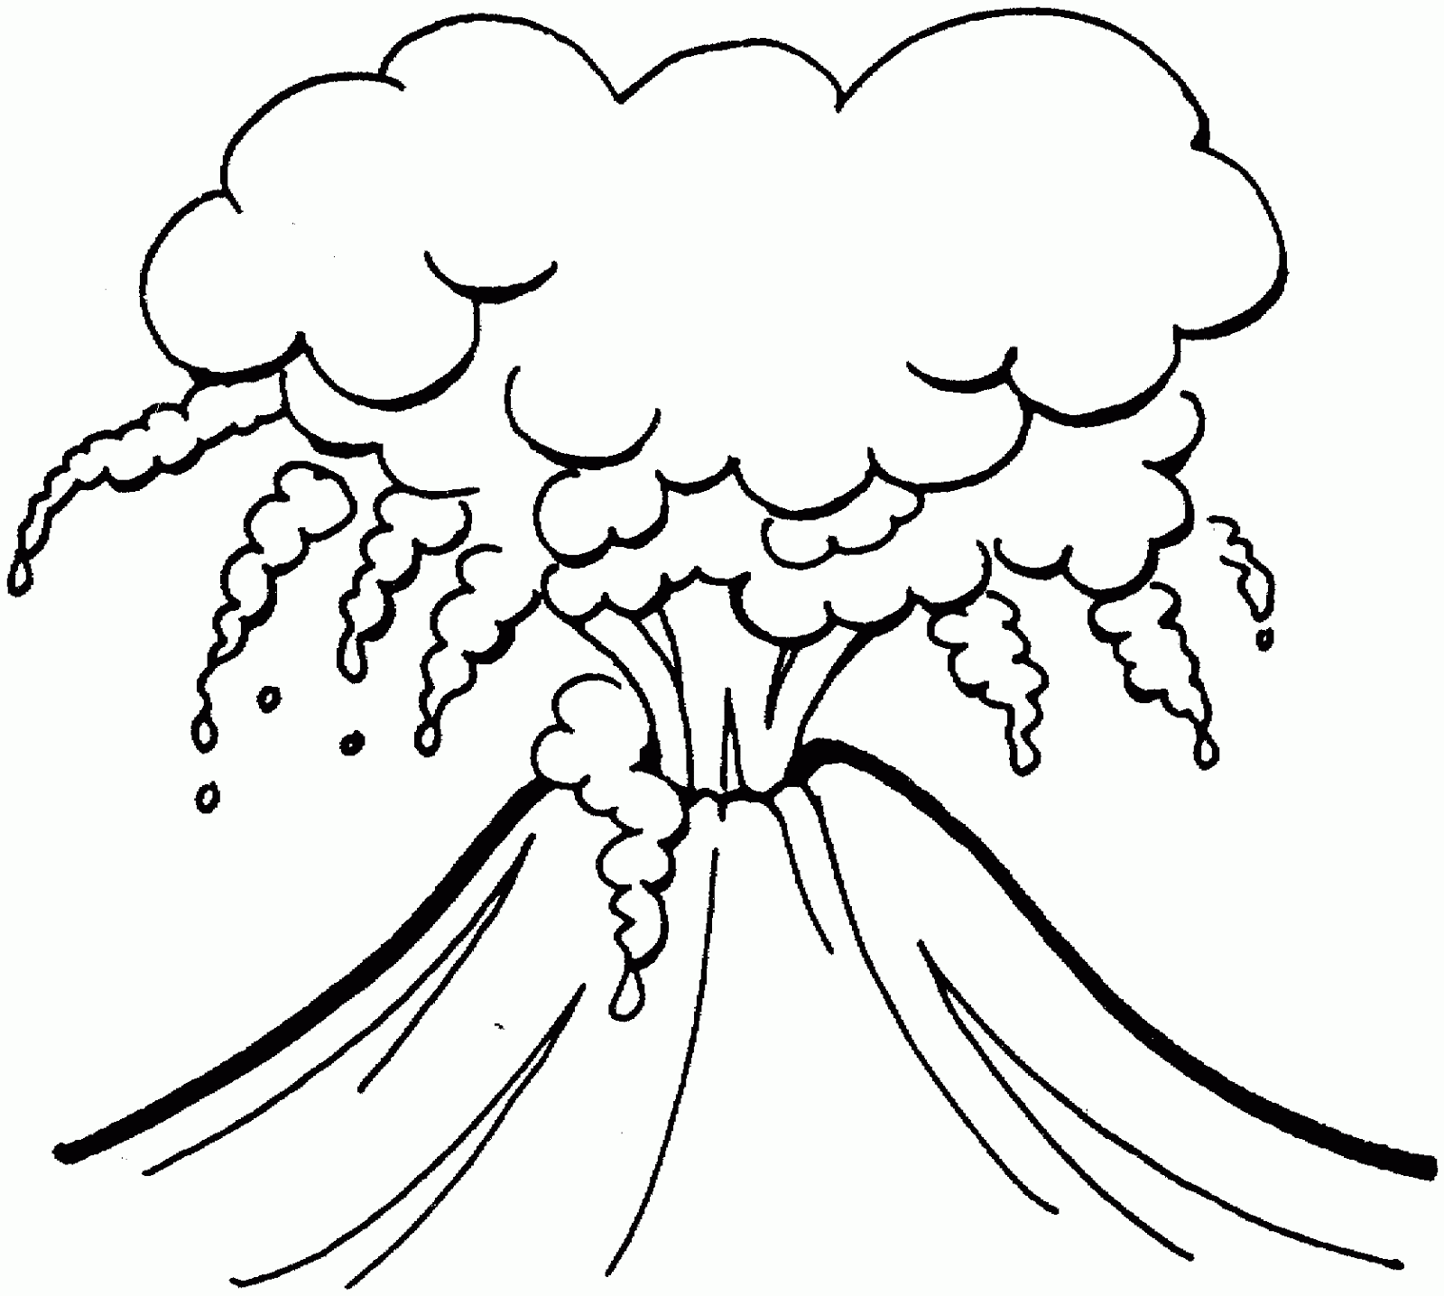

**Thunderstorm**

**Avalanches**

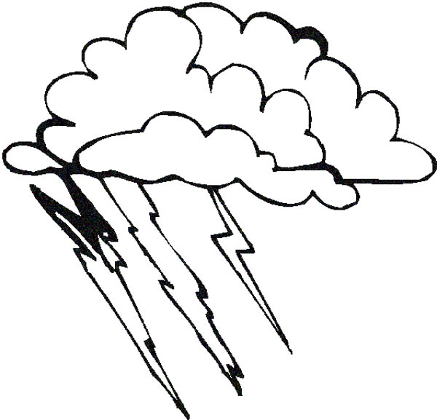

...are some of the most frightening and powerful storms to hit the world.

... are small slides of dry powdery snow that move as a formless mass.