ASIGNATURA:Inglés NOMBRE DOCENTE: Erika Ramirez
OBJETIVO A LOGRAR CON LA GUÍA DE TRABAJO: Comprensión lectora
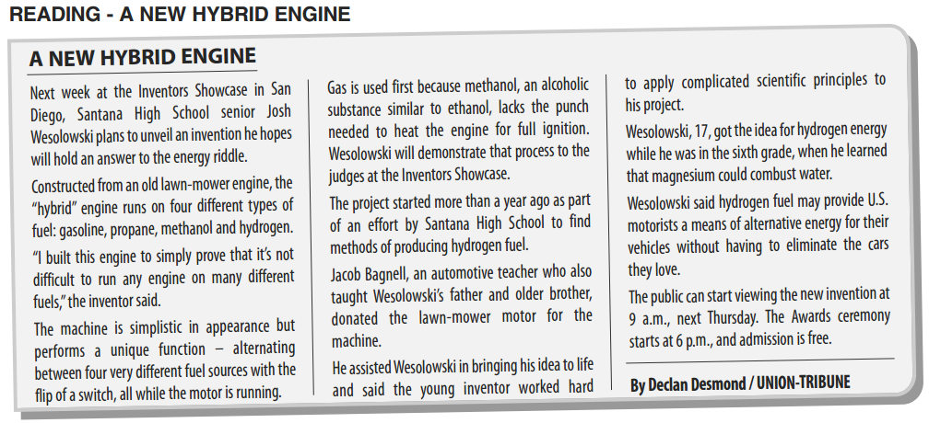

Encuentra el significado de estas palabras en el diccionario:
Hope |  | Between
Riddle |  | Source
Engine |  | While
Hybrid |  | Lack
fuel |  | Judge
Machine |  | hard
Young |  | Principles
View |  | Combust
Award |  | Without

- Responde las siguientes preguntas:

Who is Josh Wesolowski? _________________________________________________________________.
What types of fuel does the “hybrid engine” uses? ___________________________________________.
Methanol is very similar to_______________________________________________________________.
Why did the inventor started this project? __________________________________________________.
what did he used to make this invention?___________________________________________________.
who donated the material for the invention?________________________________________________.

- Verdadero (T) o falso (F)?
- ________ This text is an encyclopedia article.
- ________ The hybrid engine runs on 4 types of fuel
- ________ The inventor is sixteen years old
- ________ Josh created his invention To prove its not difficult to run engines on many different fuels.
- ________ this invention can alternate between 4 types of fuel with the flip of a switch.

