ASIGNATURA:Inglés NOMBRE DOCENTE: Erika Ramirez
OBJETIVO A LOGRAR CON LA GUÍA DE TRABAJO: Comprensión lectora

A Controversial Artist
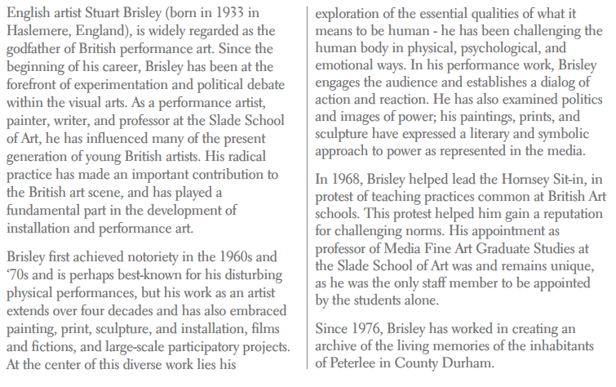
Responde las siguientes preguntas:

- What jobs has Stuart Brisley had during his career?
________________________________________________________________________.

- What made Stuart Brisley popular?
________________________________________________________________________.

- Why has he been challenging the human body?
________________________________________________________________________.

- How old is Stuart today?
________________________________________________________________________.

- What specific artistic area has he helped to develop?
________________________________________________________________________.

- What’s interesting about his appointment at the Slade School of Art?
________________________________________________________________________.

- What’s the main idea of the first paragraph?
________________________________________________________________________.

- What’s the main idea of the third paragraph?
__________________________________________________________________________.

