ASIGNATURA:Inglés NOMBRE DOCENTE: Erika Ramirez
OBJETIVO A LOGRAR CON LA GUÍA DE TRABAJO: Comprensión lectora

The history of Karate
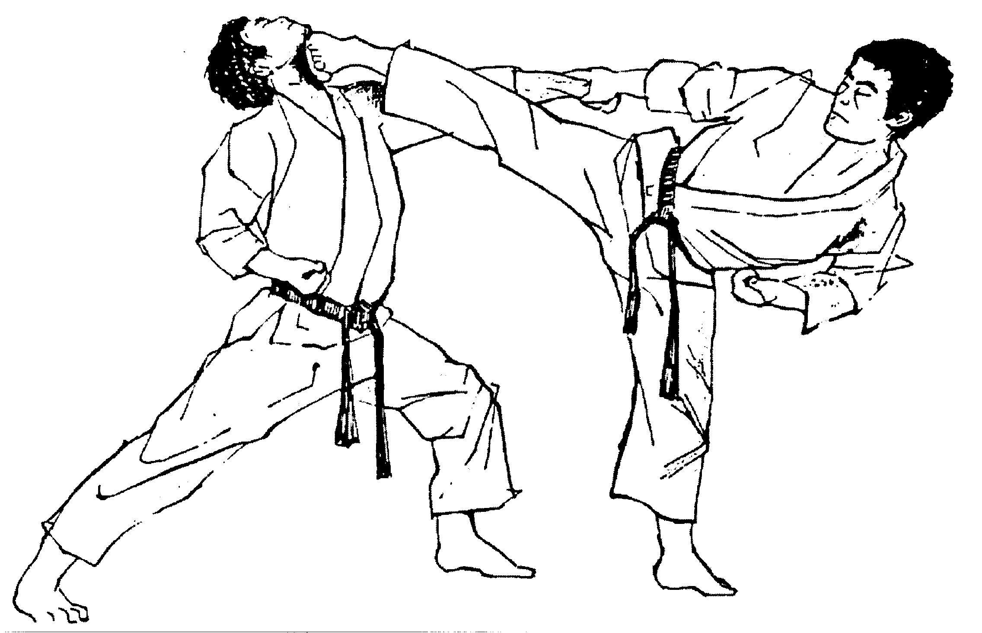
Karate is a martial art developed in the islands of Okinawa, Japan. It was created under the influence of Chinese martial arts. A karate practitioner is called a karateka.
It was brought to the Japanese mainland in the early 20th century. In 1924 Keio University established the first university karate club in Japan and by 1932, major Japanese universities had karate clubs. After World War II, Okinawa became an important United States military site and karate became popular among servicemen stationed there.
The martial arts movies of the 1960s and 1970s served to greatly increase the popularity of martial arts around the world. Karate schools began appearing across the world, catering to those with casual interest as well as those seeking a deeper study of the art.
In 2009, in the 121st International Olympic Committee voting, karate did not receive the necessary two-thirds majority vote to become an Olympic sport.
Web Japan claims there are 50 million karate practitioners worldwide, while the World Karate Federation claims there are 100 million practitioners around the world.

- Que tipo de texto es?

a) A piece of news b) a Short story c) an encyclopedia article.

- Verdadero (T) o falso (F)?

- _____ Karate was created by a Japanese named Karateka.
- _____ The first karate club in a University was created on 1932
- _____ the martial arts movies helped to increase their popularity.
- _____ Karate is practied only in Japan.
- _____ In 2009 Karate became an Olympic sport.
- _____ a lot of people practice karate over the world.

- Lee el texto y encuentra la siguiente informacion:
- The name of the person who practices karate: __________________________
- The city where Karate was created: __________________________________
- The name of the first university that established a Karate club:______________
- The year when major Japanese universities had karate clubs:_______________

